**PROJECT REPORT**

# TITLE OF THE PROJECT :-

# 

# LAB EXAMINATION PORTAL

**CERTIFICATE**

This is to certify that the project work which is entitled as “LAB EXAMINATION PORTAL” jointly submitted by Nishant, Pinki Kumari , Hemraj Kumawat and Deepali Naamdev as a part of MCA(2018-2021) of Jawaharlal Nehru University, is a bonafide work carried out under direct supervision and guidance.

**SUPERVISED BY**

Dr. KARAN SINGH

SCSS

Jawaharlal Nehru University

**DECLARATION**

We hereby declare that this Project Report titled “LAB EXAMINATION PORTAL” submitted for the partial fulfillment of the requirement for the degree of Master in Computer Application to the School of Computer and System Science is a record of original work done by us under the guidance of Dr. Karan Singh

The information and data given in the report is authenticate to the best of our knowledge.

**NISHANT**

**PINKI KUMARI**

**HEMRAJ KUMAWAT**

**DEEPALI NAMDEV**

**ACKNOWLEDGEMENT**

The satisfaction that accompanies that the successful completion of any task would be incomplete without the mention of people whose ceaseless cooperation made it possible, whose constant guidance and encouragement crown all efforts with success.

We also thank our colleagues who have helped in successful completion of the project through constant motivation and support.

We also thank Dr. Karan Singh for his support and guidance.

**NISHANT**

**PINKI KUMARI**

**HEMRAJ KUMAWAT**

**DEEPALI NAMDEV**

**Contents**

1 INTRODUCTION (1-7)

* About
* Motivation
* Challenges
* Application
* Objective
* Methodology
* Requirements
* Problem statement
* Proposed project

2. Software requirement specification. (8-10)

* Tools and technologies
  + Hardware Interface
  + Software Interface

3. Design of the proposed system (11-21)

* Modules
* layout
* Entity Relationship Diagram
* Data Flow Diagram
* schema

4. snapshots of output. (22-39)

5. analyzing project

* Market value
* Novelty
* Comparison with existing lab examination portals

6.conclusion and References

7.Manuals and Appendices (Source code) (42-81)

# CHAPTER 1

# About:-

This software will let students as well as faculties to not to face the problems due to the various IDE not installed in the system during laboratory examination. This LAB EXAMINATION PORTAL will resolve the problem of generating pen paper based questions and keeping track of the time involved.

This portal consist of a compiler which will compile/interprete the major languages like C, JAVA, PYTHON,c++,PYTHON3,PHP,JAVASCRIPT,JAVA8.

# MOTIVATION:-

Examinations have been always a reason for anxiety in students. Imagining a situation where a student in his/her lab examination is stuck with the “not responding IDE ” or not getting a supporting IDE on the allocated system is furious and hence backs this software.

# CHALLENGE:-

Designing an IDE which will compile all the three languages and designing a system which will conduct student’s online examination by providing questions and keeping track of the time was a big challenge.

# APPLICATION:-

It can be used in any institutions/organisations to serve the purpose of online coding examination.

# OBJECTIVE :-

* To create an application for the school of computer and system sciences, JNU which will smoothen the conduct of practical coding examination by allowing faculties to post the problem statements and letting student to attempt for a solution.
* This IDE will serve as a common platform for compiling/interpreting and running languages like java , c ,c++ , php ,javascript and python.
* This will help the organization to conduct practical examination without the use of internet.

# Methodology

(I)**Identifying the prerequisite of the project:**

* As we know necessity is the mother of inventions. so what let us think over this portal should be clear. So our first step towards this project was problem formulation.
* Deciding the tools to implement this project.

(II)**Identifying various components and entities present in the system.**

* deciding the attributes to be kept in a entity.

(III)**Identifying all the relation between various entities**.

* Identifying the type of relation and deriving a relational mapping between various entities.
* Designing a DFD.
* Designing an E-R diagram.

(IV)**Designing front end.**

(V)**Creating a database.**

(VI) **Applying this relationship among entities to perform various queries in the database.**

(VII) **Using these queries to generate desired results and display it on the user interface by means of a server- scripting language and mark-up language.**

# REQUIREMENTS :-

Front end :- HTML 5 ,CSS 3,ANGULAR,Material Design.

Back end :- , PHP 7.

Database server :- MySql.

# PROBLEM STATEMENT:-

To develop a system to ease the task of faculties as well as students which will not only provide the problem of corresponding subject but also provide the suitable IDE and keep the track of time.

# PROPOSED PROJECT:-

## ABOUT:-

This software will let students as well as faculties to not to face the problems due to the various IDE not installed in the system during laboratory examination. This LAB EXAMINATION PORTAL will resolve the problem of generating pen paper based questions and keeping track of the time involved.

This portal consist of a compiler which will compile/interprete the major languages like C, JAVA, PYTHON.

## MODULES :-

* REGISTRATION
* LOGIN
* ADMIN
* STUDENTS

## FEASIBILITY :-

The major modules which will take the large part of the total time is “ ADMIN” and “ STUDENTS” due to huge research involvement. Broadly this application will take two months in it’s completion.

## 

## 

## CHAPTER 2

**Software Requirement Specification**

This project student Portal has been developed with the use of HTML, CSS, angular and material design as front end tools and guidelines and larvel, Mariadb as backend development tools and XAMPP as the localhost.

**Technology used:**

1) Hardware interface

System configuration: 4 GB DDR4 RAM

Operating system: 64 bit Windows 10 OS

2) Software interface

Front end: Html, Css , angular, material design

Back end: laravel

Local server: Xampp v 3.2.2

DBMS server: mariadb

**XAMPP**

Xampp stands for Apache, mysql, php and perl. It is a localhost server required for the processing of php program execution and database connection. We have used version 5.6 in our project.

**MariaDB**

MariaDB Server is one of the most popular open source relational databases. It’s made by the original developers of MySQL and guaranteed to stay open source. It is part of most cloud offerings and the default in most Linux distributions.

It is built upon the values of performance, stability, and openness. Recent new functionality includes advanced clustering with Galera Cluster 4, compatibility features with Oracle Database and Temporal Data Tables, allowing one to query the data as it stood at any point in the past.

**laravel**

**Laravel** attempts to take the pain out of development by easing common tasks **used** in the majority of web projects, such as authentication, routing, sessions, and caching. **Laravel** aims to make the development process a pleasing one for the developer without sacrificing application functionality. Laravel is a web application framework with expressive, elegant syntax.

In this project we are using laravel 7.11.0.

**HTML AND CSS**

HTML stands for Hypertext Markup Language and CSS stands for Cascading Style Sheets are the crucial technologies for creating web pages. HTML supplies the structure of the page, and CSS the layout, for diversity of devices. Together with scripting and graphics, HTML and CSS are the fundamental of building Web Applications and Web pages.

**ANGULAR**

Angular is an application design framework and development platform for creating efficient and sophisticated single-page apps.

It is a [TypeScript](https://en.wikipedia.org/wiki/TypeScript" \o "TypeScript)-based [open-source](https://en.wikipedia.org/wiki/Open-source) [web application framework](https://en.wikipedia.org/wiki/Web_framework) led by the Angular Team at [Google](https://en.wikipedia.org/wiki/Google) and by a community of individuals and corporations. Angular is a complete rewrite from the same team that built [AngularJS](https://en.wikipedia.org/wiki/AngularJS" \o "AngularJS).

# CHAPTER 3

## MODULES :-

* REGISTRATION
* LOGIN
* ADMIN
* STUDENTS

## LAYOUT OF THE PROJECT:-

**HOME PAGE**

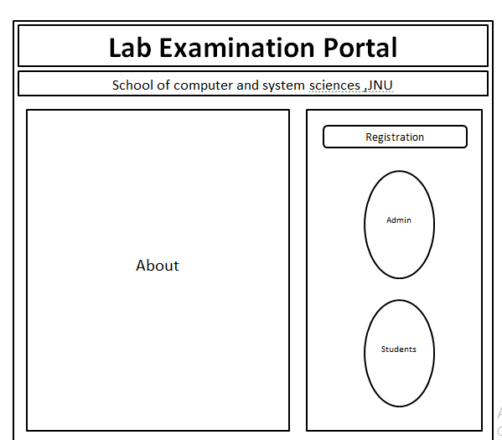

**ADMIN**

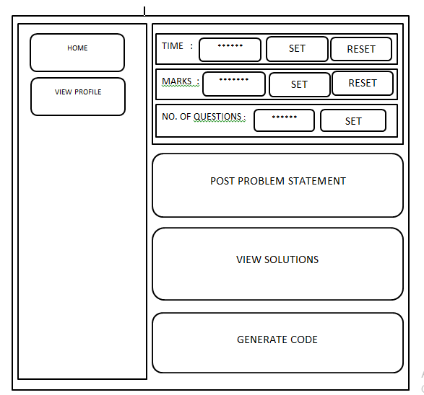

**STUDENTS**

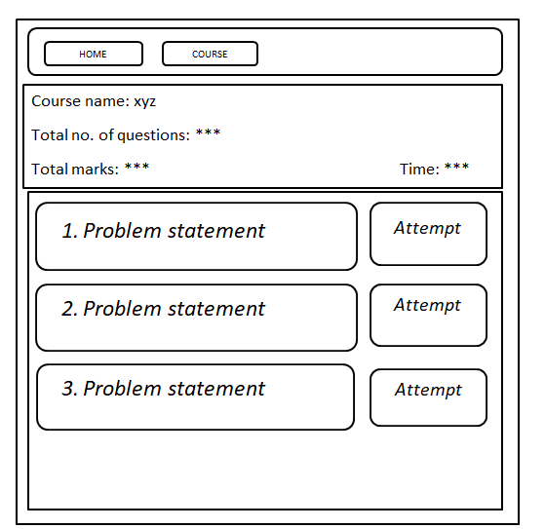

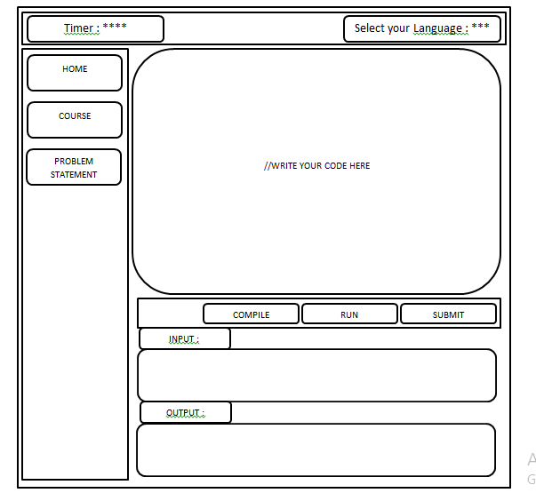

# E-R DIAGRAM:-

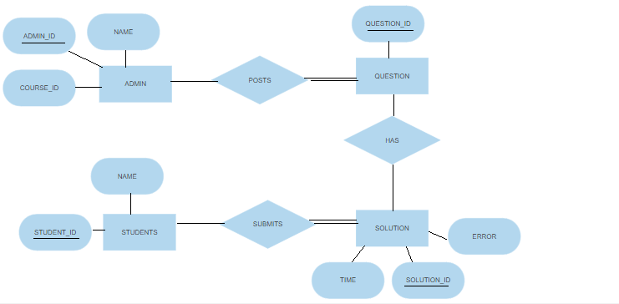

## DATA FLOW DIAGRAM:-

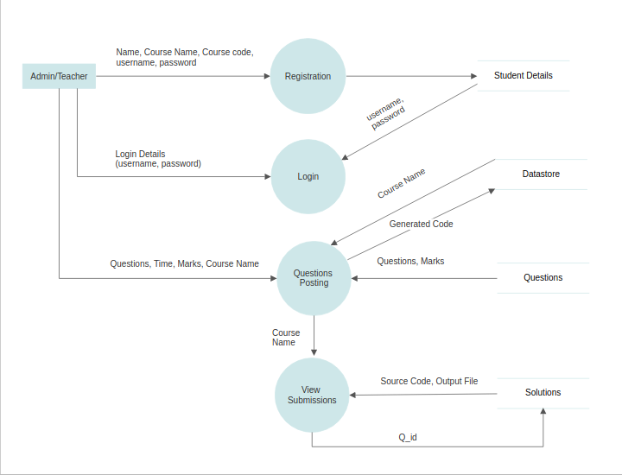

# 

# TABLES:-

USERS

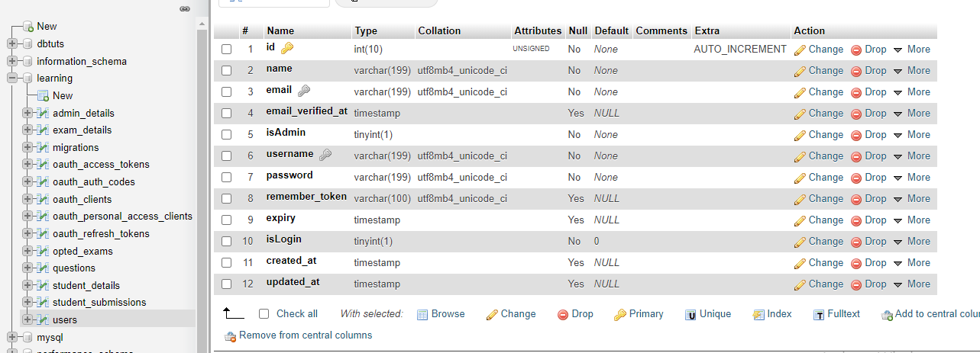

STUDENT SUBMISSION

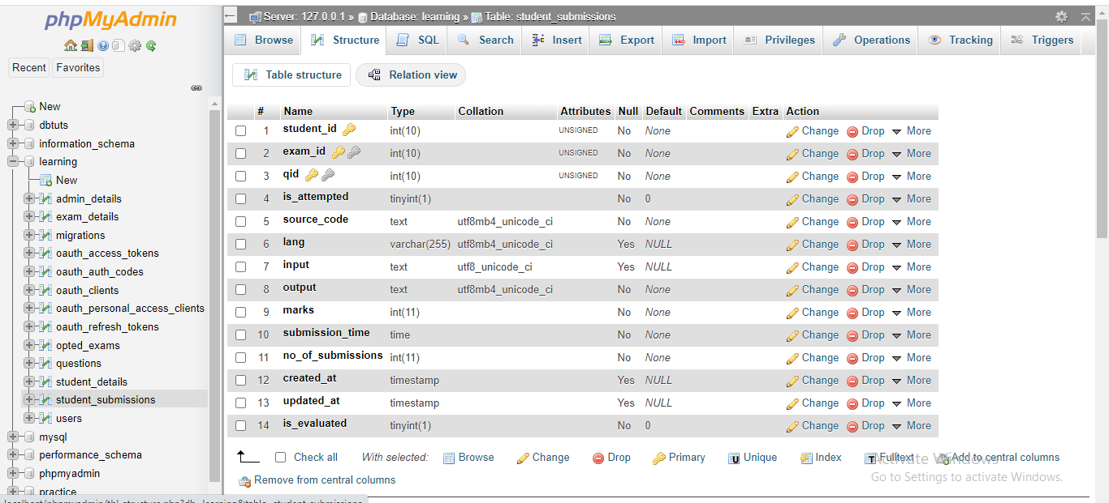

STUDENT DETAILS

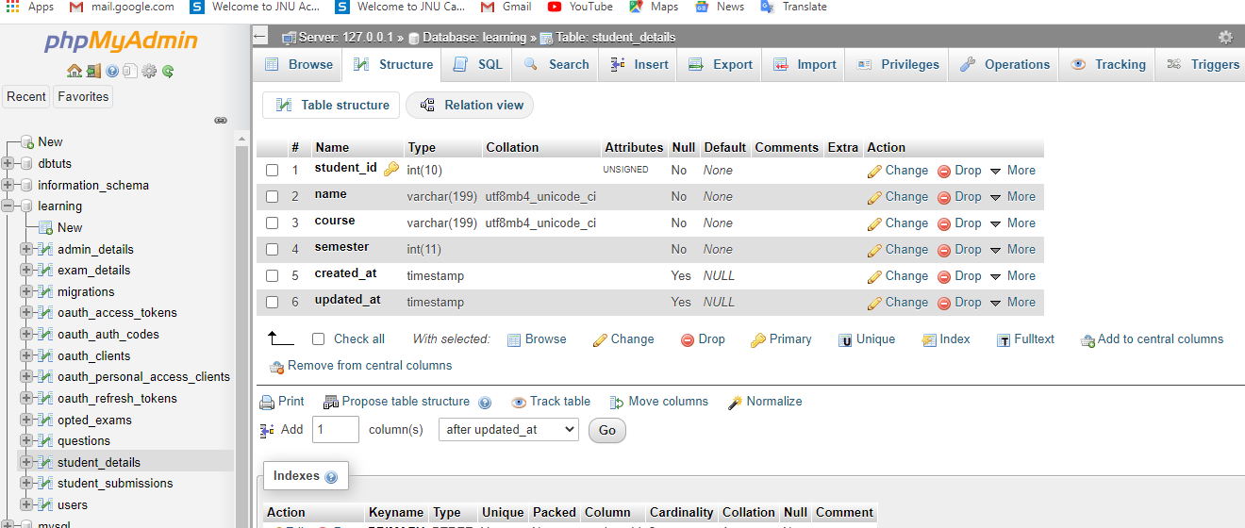

QUESTIONS

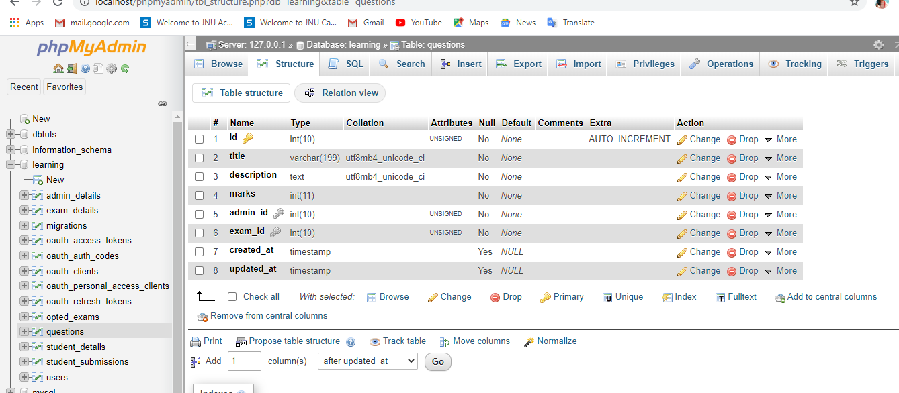

OPTED EXAMS

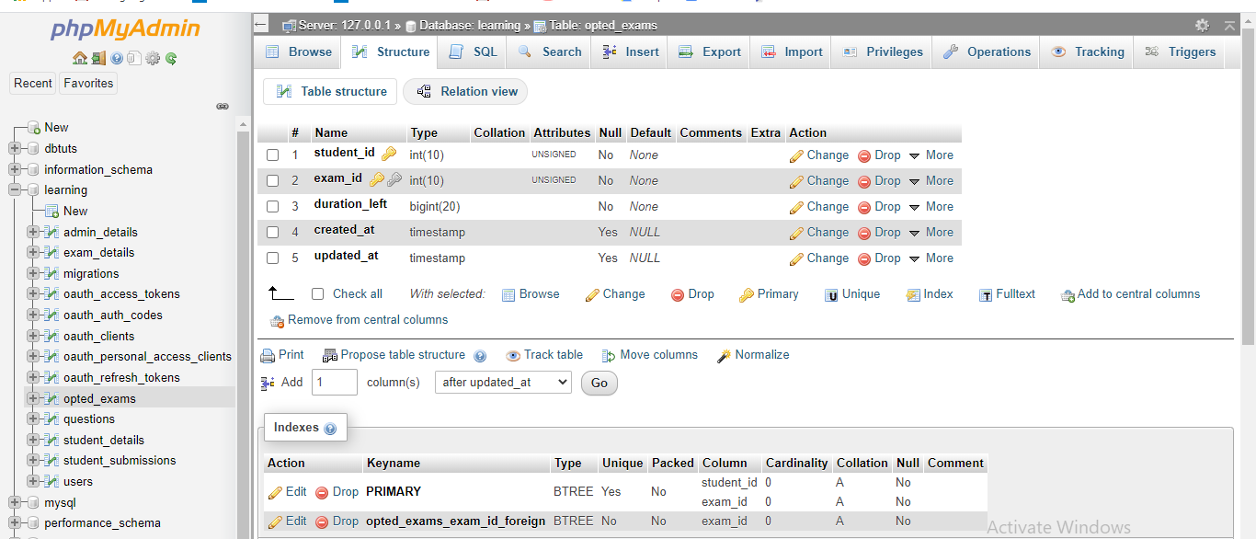

OAUTH PERSONAL ACCESS CLIENTS

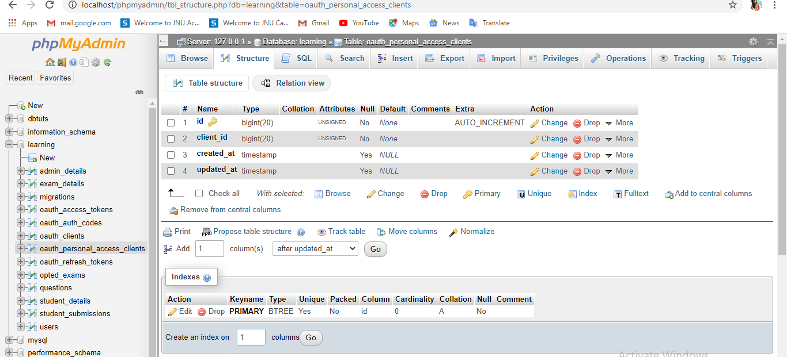

OAUTH CLIENTS

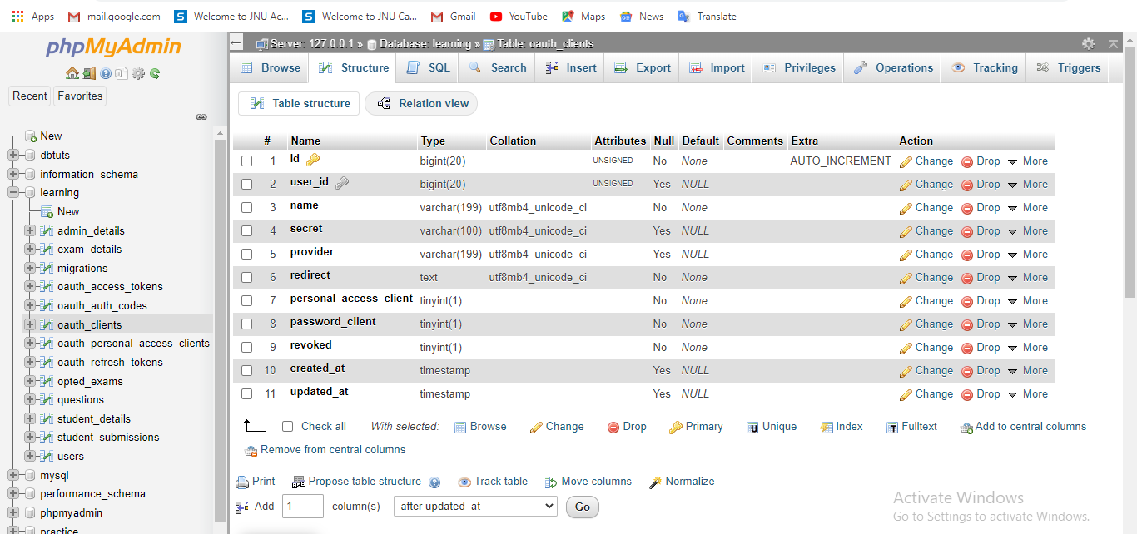

OAUTH AUTH CODES

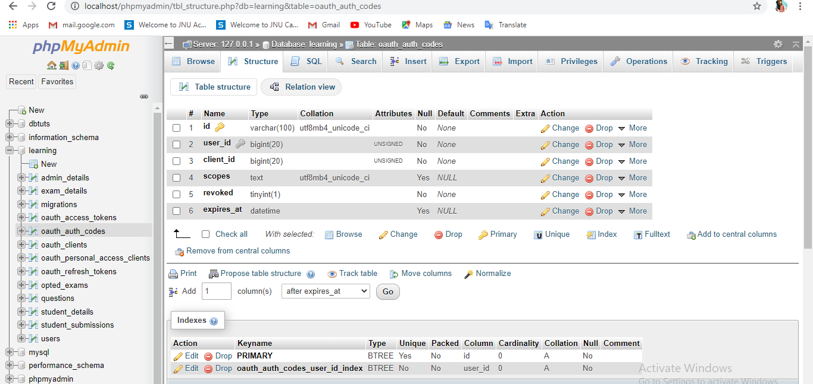

MIGRATIONS

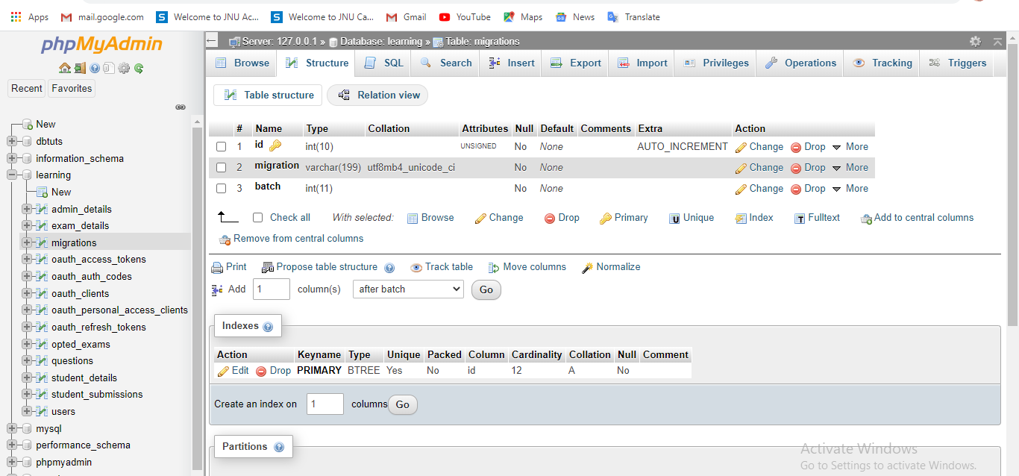

OAUTH ACCESS TOKENS

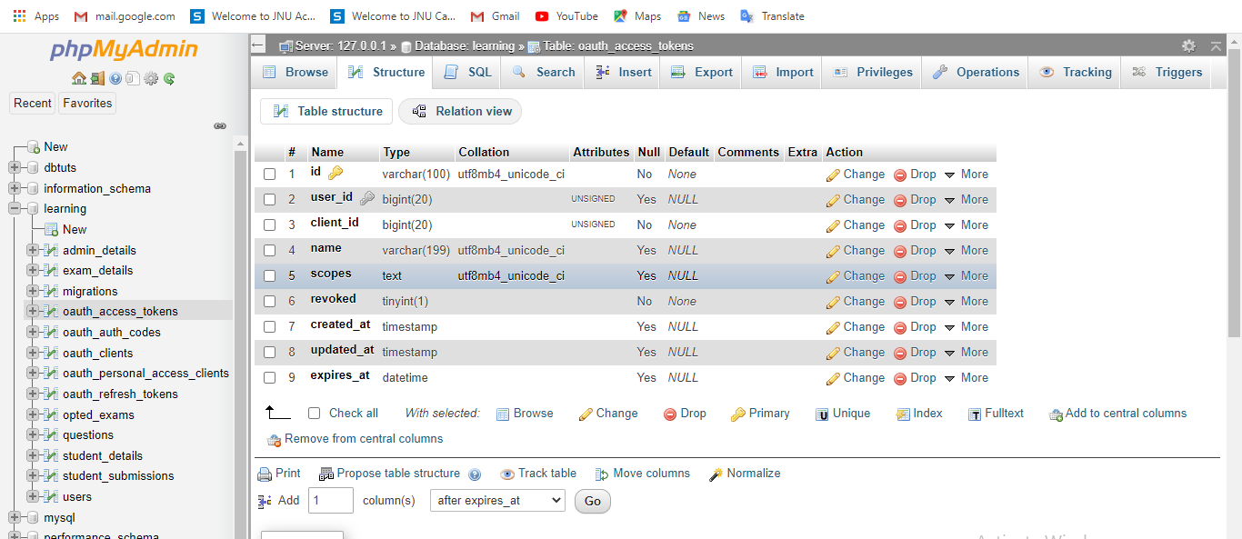

EXAM DETAILS

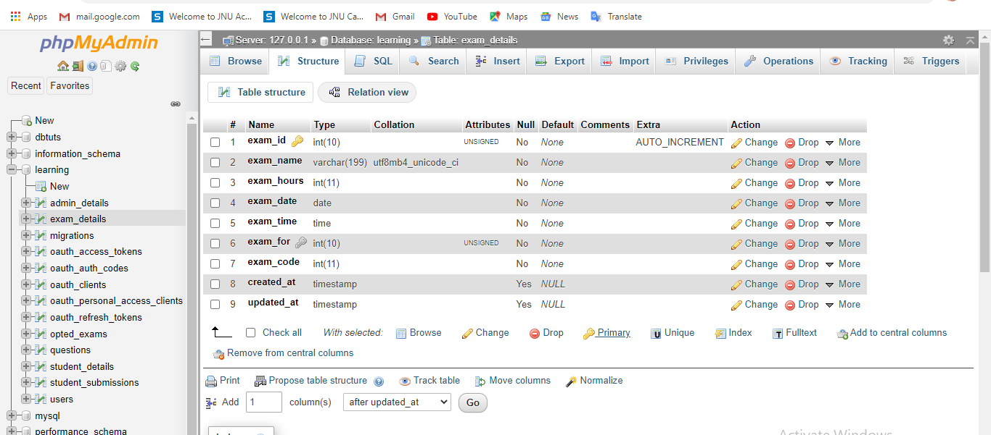

ADMIN DETAILS

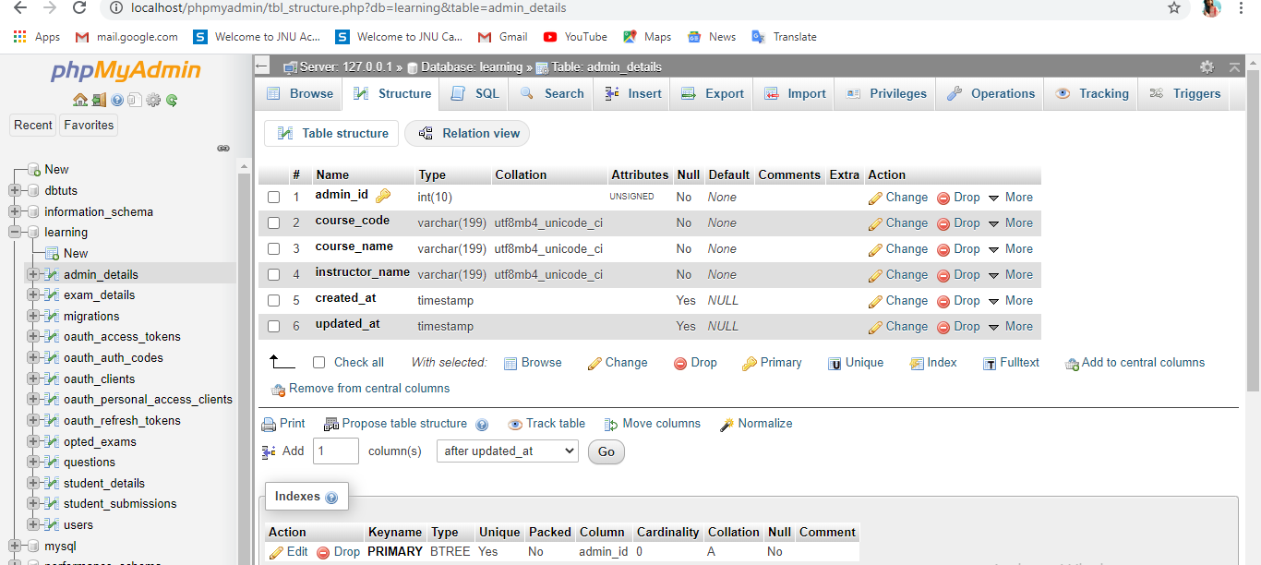

## CHAPTER 4

## SNAPSHOT OF OUTPUT :

## 

## CHAPTER 5:

## MARKET VALUE:

This project is an enterprise wide project developed to meet the requirements of school of system and computer sciences ,JNU.

## NOVELTY:

Though this project is not bringing something new in the light but despite not being the peculiar one it possess some special properties which will not only ease the task of institution but also help students in relieving them from the hardship of app failure by providing an examination portal which will compile all the major languages like C ,JAVA ,PYTHON ,C++ etc. all on one platform.

It would smoothen the student task and hence will boost their confidence and assure to provide the facility without internet connectivity.

## COMPARISON WITH EXISTING LAB EXAMINATION PORTALS :

None of the existing lab examination portal possess the property of compiling and interpreting these many languages without the requirement of internet connectivity at the client side.This makes it odd from the existing ones.

## CHAPTER 6

## CONCLUSION:

This “LAB EXAMINATION PORTAL” project is successfully developed under the supervision of DR. KARAN SINGH for the course work of web designing ,MCA IV, to ease the lab examination and to be deployed in the SCSS ,JNU.

## REFERENCES:

## https://laravel.com/docs/7.x

## <https://stackoverflow.com/>

<https://laravel.com/docs/7.x/passport>

<https://www.youtube.com/watch?v=rDJ7BebkNso&list=PLYVcyg3AF-zvDDXBLDyn9UJSgAYMWpUS3>

<https://angular.io/docs>

## USER MANUAL:

* Users are needed to register first
* After creating an account, user can login anytime.
* To commence an exam admin needs to create an exam and provide students the unique exam code .
* Source code of user will be saved automatically.
* Once the time is over ,student can’t modify their code.
* Instructor can add ,edit and delete the question the questions of exam that is yet to be started.
* Instructor can create and delete the exam that is yet to be started.
* Once exam is over, instructor can check the submissions and give marks.
* Instructor details can be changed by the current instructor if he/she handovers the course to another instructor.

## DEVELOPER MANUAL:

* To access APIs, navigate to labExamPortal/ labExamPortal/routes.php
* To access models, navigate to labExamPortal/ labExamPortal/app
* To access controllers, navigate to labExamPortal/ labExamPortal/app/http/api/controllers
* To access migration files, navigate to labExamPortal/ labExamPortal/database/migrations